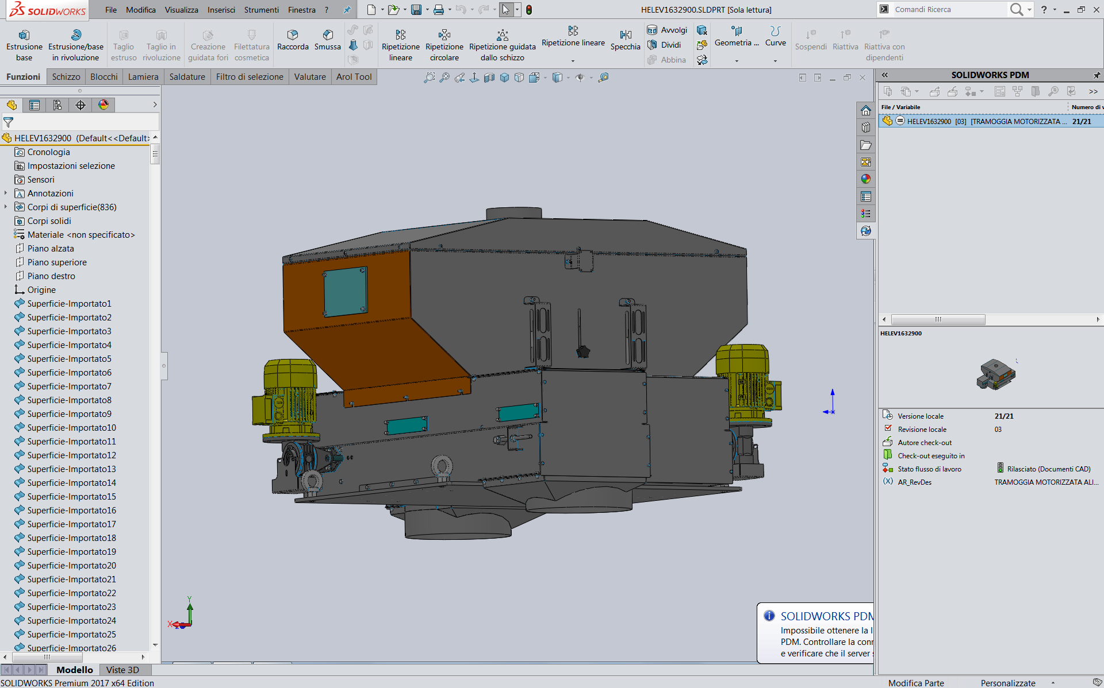

**M11A21**

**B33A3**

**B33A1**

**M11A1**

**B33A2**